18th Annual WCCTA Conference

Sleeping Lady Resort and Conference Center
Leavenworth, WA

October 7th – 9th, 2010

Hosting Institution
Central Washington University
Ellensburg, WA

Organizers:
Martha Kurtz, Tim Sorey, Anne Johansen, Yingbin Ge
Linda Kuehnert
Washington College Chemistry Teachers Association
2010 Conference Program At A Glance

Thursday, October 7, 2010
3:00 – 10:00 pm | Check-in (Sleeping Lady Main Office)
4:30 – 10:00 pm | Conference Registration (Woodpecker)
6:00 – 7:30 pm | Dinner (Kingfisher Dining Lodge)
8:00 – 10:00 pm | Evening Social: No-Host Bar  SongWeavers – a night of science music and fun  (please bring your own instrument to play along)

Friday, October 8, 2010
7:30 – 8:30 am | Breakfast
8:45 – 9:00 am | Welcome – Chapel Theatre
9:00 – 10:15 am | Keynote Address  George Kriz, Western Washington University  “Reflections on a Career in Chemical Education”
10:15 – 11:00 am | Vendor Break, Salmon Gallery
 | Chapel Theatre | Woodpecker |  | Flicker
11:00 – 11:50 am | Gina Fiorini & Jennie Mayer  (Bellevue)  Karyn Mlodnosky (Cascadia)  “Open Course Library Project: CHEM& 121 (Introductory Chemistry)” | Kathy Carrigan & Kenneth Friedrich (Portland CC)  “Hands on Experience with at Home Labs for online chemistry course” |  | Christopher Coughenour & Dharshi Bopegedera (Evergreen)  “Earth Matters: Successes and challenges in teaching an integrated chemistry-geology course”
12:00 – 1:00 pm | Lunch
1:10 – 1:35 pm | Jacqui Drak, Gina Fiorini, Jennie Mayer Dan Mitchell (Bellevue)  Marie Villarba & Doug Wick  (Seattle Central)  “Open Course Library Project: CHEM& 161/162/163 (General Chemistry)” | Patricia Hill (Millersville U) &  Deberah Simon (Whitman)  “Chemistry, Art and Cultural Diversity” |  |  | Ted Baldwin & Katy Baldwin (Olympic College)  “Molecules: A brief chemical description and introduction to societal impacts: A linked poster project between students from Chemistry and Sociology”
1:35 – 2:00 pm |  |  |  |  | Martha J. Kurtz (CWU)  “What are your students really thinking?”
2:00 – 2:30 pm | Vendor Break, Salmon Gallery
 | Chapel Theatre | Woodpecker |  |  | Flicker
2:30 – 3:20 pm | Robert Rittenhouse (CWU)  “New Insights into Close-Packed Lattice Structures Using Primitive and Non-Primitive Unit Cells” | Patricia Hill (Millersville U) &  Deberah Simon (Whitman)  WORKSHOP: “Chemistry in Art” |  |  | Nadine Fattaleh (Clark)  John Thompson (Lane CC) &  Katie Gulliford (Tacoma CC)  WORKSHOP:  “Strategies and Opportunities in Green Lab Writing”
3:30 – 4:20 pm | Laura Frost (Georgia Southern U)  “Meeting the Needs of Health Professions Students by Integrating Chemical Topics and Guided Inquiry”
4:30 – 6:30 pm | Cengage Reception - Salmon Gallery |  | Break: Free Time!
6:30 – 7:30 pm | Dinner
8:00 – 10:00 pm | After Dinner Talk: Amy Mumma, CWU World Wine Program Coordinator  “Where Art and Science Meet in the Glass”  Wine Tasting and No-Host Bar, Woodpecker

Saturday, October 9, 2010
8:00 – 9:00 am | Breakfast
 | Woodpecker | Flicker
9:10 – 9:35 am | Adam Wolfer & Jerry Zimmerman (Lower Columbia)  “The Genie in the Flask: Integrating Chemistry and Humanities” | Deanna D. Ojennus & Drew Budner (Whitworth)  “Service Learning in Chemistry at Whitworth University”
9:40 – 10:30 am | Roundtable: General Chemistry | Roundtable: GOB & Organic
10:30 – 11:00 am | Break and Check-out by 11 am
11:10 – 11:50 am | Business Meeting – Woodpecker
12:00 – 1:00 pm | Lunch
1:00 pm | Have a safe drive home!

Program Details

Thursday Evening Event October 7, 2010

8:00 – 10:00 pm
An Evening of Music and Fun Woodpecker
SongWeavers
Colleen Renee
Dan Shissler

In addition to traditional sing along folk songs, the SongWeavers will perform science songs written by Greg Crowther, Research Scientist at the University of Washington Department of Medicine. Please bring your own musical instruments to join Dan and Colleen in a night of song. A no-host bar will be available.

Offering folk classics, sing alongs and original compositions, The SongWeavers - a diverse acoustic folk duo - features Dan Shissler and Coleen Renee. Their unique mix of humor, story and teaching songs are woven together with sweet and often intricate harmonies. Coleen and Dan have played music together for several years and are available to sing for various occasions. They live and sing in Ellensburg, Washington and can be reached at 509-312-0220.

Friday Keynote Address October 8, 2010

9:00 – 10:15 am Chapel Theatre

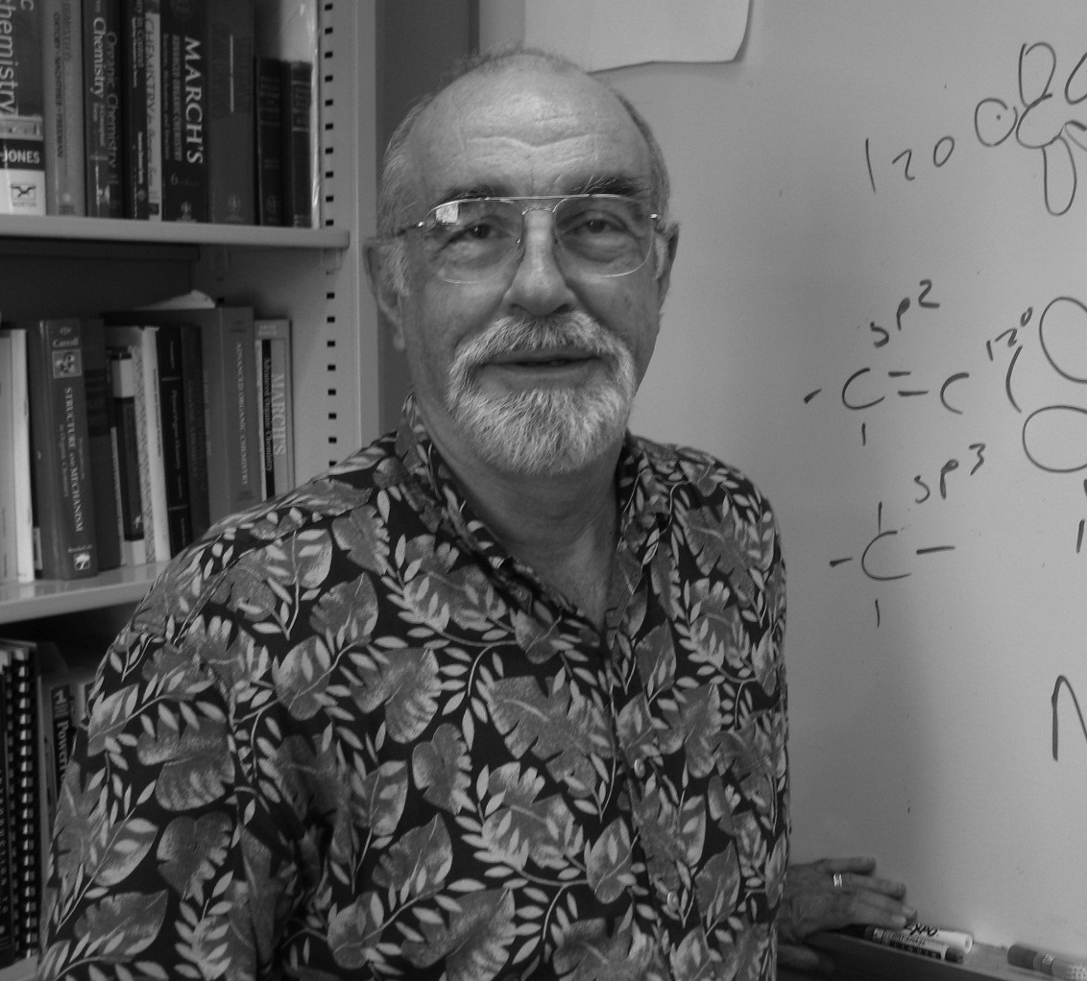
“Reflections on a Career in Chemical Education”

George S. Kriz, Western Washington University
Professor of Chemistry and Acting Department Chair

George, a long time member of WCCTA is a scientist, a scholar, an advisor, but most of all he is a teacher. With a Bachelor of Science degree in chemistry from the University of California (Berkeley) and a Ph. D. in organic chemistry from Indiana University, he began his academic career in 1967 at what was then called Western Washington State College. Forty-three years later he continues as Professor of Organic Chemistry at Western, but in recent years he has branched out into teaching chemistry for a general student audience – the “Chemistry for Poets” course and introducing the elements of Green Chemistry into the organic laboratory curriculum. He considers himself especially fortunate to be able to devote his life to something that continues to be so rewarding and at an institution that has supported him in many ways throughout his career. He is also Director of Pre-Healthcare Professions Advising, which means that he am responsible for all pre-medical, pre-dental, pre-pharmacy, and other pre-healthcare programs on this campus. For this year, He is also serving as Acting Chair of the Department of Chemistry at WWU.

His research interests range from determining the structures of organic molecules by spectroscopic methods to developing new ways of teaching organic and general chemistry courses. Together with his colleagues Donald L. Pavia, Gary M. Lampman, Randall G. Engel, and James R. Vyvyan, he has co-authored a series of successful organic chemistry textbooks, including Introduction to Organic Laboratory Techniques: A Microscale Approach, Introduction to Organic Laboratory Techniques: A Small Scale Approach, Introduction to Spectroscopy: A Guide for Students of Organic Chemistry, and Microscale and Macroscale Techniques in the Organic Laboratory. In 2000, he was awarded the Peter J. Elich Excellence in Teaching Award from Western Washington University. He regards this recognition with great pride. Most recently, he was awarded the 2010 Distinguished Service Award by the Division of Chemical Education of the American Chemical Society.

George actively participates in several societies devoted to the teaching of chemistry; among these are the American Chemical Society and its Divisions of Organic Chemistry and Chemical Education, the National Science Teachers Association, the National Association for Research in Science Teaching, Sigma Xi, the Washington College Chemistry Teachers Association, and the National Association of Advisors for the Health Professions. He served as chair of the Biennial Conference Committee of the Division of Chemical Education for many years, and in the summer of 2002, he was the General Chair of the 17th Biennial Conference on Chemical Education at Western Washington University. He continues serving the chemical education community through his membership on several ACS task forces devoted to improving the teaching of chemistry in two-year programs.

For fun, he is an active member of the bass section of the Whatcom Chorale and a long-time season ticket holder at the Seattle Opera. His annual New Year’s resolution is to play more golf. However, the greatest fun he has is in the classroom.

Friday Morning Abstracts October 8, 2010

11:00 – 11:50 am

“Open Course Library Project: CHEM& 121 (Introductory Chemistry)” Chapel Theatre

Gina Fiorini, Bellevue
Jennie Mayer, Bellevue College
Karyn Mlodnosky, Cascadia Community College

“The Open Course Library project is about designing high enrollment, gatekeeper and pre-college courses for face-to-face, hybrid and/or online delivery, to improve course completion rates, lower textbook costs for students, provide new resources for faculty to use in their courses, and for our college system to fully engage the global open educational resources discussion.”
(from Open Course Library project overview)

We are in the process of designing CHEM& 121 (Introductory Chemistry) for the Open Course Library project, which is part of the Washington State Student Completion Initiative. We see this as an opportunity to engage in rich discussions among faculty in our system and to provide a high quality course that would be useful to our colleagues and provide guidance to new faculty. Challenges of this project include finding appropriate low cost materials, writing course objectives that address the varied populations that take this course, and designing/choosing labs that enrich the curriculum, yet are accessible to those without expensive lab equipment.

Participants will be given a brief overview of the project and current state of course design. We will then engage in small group discussions around course outcomes, instructional materials, labs and assessments. Ideas from the small groups will then be shared and discussed. Our aim is to gain valuable input and feedback from our peers. Additionally, we would like to begin a discussion amongst the community around repositories for sharing resources, such as labs, exam and homework questions, activities, etc.

Note: A similar session focusing on general chemistry will be presented in a separate session.

11:00 – 11:50 am

“Hands on Experience with at Home Labs for online chemistry course” Woodpecker

Kathy Carrigan, Portland Community College
Kenneth Friedrich, Portland Community College

Teaching chemistry fully online, including a “hands-on” laboratory component, is a reality and the results are impressive. Kathy Carrigan, Portland Community College (Portland, OR) Chemistry Department Chair, and Kenneth Friedrich, PhD., Instructor of Chemistry present perspective, best practices, communication methods, student interaction and feedback, as well as learning results from teaching chemistry online with an at home “wet lab” experience from LabPaqs. Carrigan and Friedrich present specific innovative and science-specific online methodologies, interactive multimedia formats, Web2.0 tools, and student lab experiences. Workshop participants will have the opportunity to perform parts of science lab performed independently by students outside the campus lab.

11:00 – 11:50 am

“Earth Matters: Successes and challenges in teaching an integrated Flicker
chemistry-geology course”

Christopher Coughenour, The Evergreen State College
Dharshi Bopegedera, The Evergreen State College

Chemistry and geology are generally approached separately in the college classroom with little exploration of the numerous connections between disciplines. The opportunity to offer a course that focuses on skill building and cross-disciplinary integration is rare, even at institutions that promote interdisciplinary instruction. Despite the interconnectedness of the topics, there are few past experiences from which instructors may draw inspiration. Accordingly, during the process of planning and execution of the course we encountered distinct successes and challenges.

Finding points of integration was essential in providing students an appreciation of both disciplines and a broader perspective of their utilization to study Earth matter and processes. This search for integration was also important in the faculty experience, motivating creation of novel laboratory exercises, student projects, lecture discussions, analysis of primary literature, and integrated field trips. The execution of the instruction process required consistent efforts, a creative approach to teaching familiar topics, and weekly evaluations of the direction and merits of the curriculum.

Integrating introductory-level topics in chemistry and geology proved most difficult during early phases of vocabulary and concept building, which were essential for providing a platform for later studies. Once fundamental concepts, such as atomic structure, bonding, geologic time, and plate tectonics were introduced, mineralogy served as the first strong point of integration. Chemical analyses of geologic samples such as marble and limonite provided other points of integration to discuss quantitative analyses and acid-base chemistry and how they relate to the composition and formation of Earth materials. Collecting samples in the field, analyzing their geologic context, and performing laboratory analyses, provided strong reinforcement of common skills used in the laboratory and field.

In this presentation we will share experiences from our course and invite the audience to participate in hands-on exercises that may be used as teaching tools in their courses.

Friday Afternoon Abstracts October 8, 2010

1:10 – 2:00 pm

“Open Course Library Project: CHEM& 161/162/163 Chapel Theatre
(General Chemistry)”

Jacqui Drak, Bellevue College
Gina Fiorini, Bellevue College
Jennie Mayer, Bellevue College
Dan Mitchell, Bellevue College
Marie Villarba, Seattle Central Community College
Doug Wick, Seattle Central Community College

“The Open Course Library project is about designing high enrollment, gatekeeper and pre-college courses for face-to-face, hybrid and/or online delivery, to improve course completion rates, lower textbook costs for students, provide new resources for faculty to use in their courses, and for our college system to fully engage the global open educational resources discussion.”
(from Open Course Library project overview)

A team of six faculty are designing CHEM& 161/162/163 (General Chemistry) for the Open Course Library project, which is part of the Washington State Student Completion Initiative. We see this as an opportunity to describe the project as a low-cost curriculum which can act as a resource, not a mandate. While still in the early stages of development, we hope to gain valuable feedback from faculty about course structure, instructional materials (many of which are “open”), and continued sharing of pedagogical resources within our WCCTA network and beyond.

A panel of faculty serving on this project will give a brief overview and current progress. We will engage in small group discussions focusing on different aspects of the project. These ideas will be discussed with the larger group. Opportunities for collaboration are welcome and will also be discussed.

Note: A similar session focusing on introductory chemistry will be presented in a separate session.

1:10 – 2:00 pm

“Chemistry, Art and Cultural Diversity” Woodpecker

Patricia Hill, Millersville University, PA
Deberah Simon, Whitman College

Typically chemistry classes provide few opportunities to address issues of cultural diversity. However, in courses that combine the study of science and art, diverse cultural heritages can be examined from both perspectives giving students a better understanding of the meaning of being human. The Center for Workshops in the Chemical Sciences (CWCS) sponsors a workshop for college faculty who wish to integrate chemistry and art in their curricula. This presentation will highlight the CWCS workshop and offer several examples of assignments and laboratory activities, which weave together the study of artists’ materials and techniques with an appreciation of the role of art in cultural identity and cultural issues in modern society.

1:10 – 1:35 pm

“Molecules: A brief chemical description and introduction to societal impacts - Flicker
A linked poster project between students from Chemistry and Sociology”

Ted Baldwin, Olympic College
Katy Baldwin, Olympic College

Most of us who teach chemistry are fascinated by the bizarre rules that govern the submicroscopic world and the language we have defined to describe it. The math used to understand, discover and make predictions about the chemical world from the subatomic to the planetary interactions and beyond become second nature to us. At times we struggle with the challenge of sharing our enthusiasm for the subject with beginning or non-science students.

Learning communities are a great way to show students that the themes central in chemistry have applications in many other fields. One of the challenges of learning communities at community colleges is making them available for students with varying workloads and schedules. At the Olympic College Learning Communities Retreat in the Spring of 2010 it was suggested that linked projects between classes could be a way to expand access for those who find it hard to enroll in a 12-15 credit learning community.

In the Summer of 2010 we had a linked project between an Intro to Sociology class and a General Chemistry Prep class. We are going to share with you the basic parameters of the project, some of the student posters, and what we thought worked well and what we will change when we do it in the future.

1:35 – 2:00 pm

“What are your students really thinking?” Flicker

Martha J. Kurtz, Central Washington University

Are your students leaving your classroom with solid conceptual understanding of chemical concepts? Research on how students learn science indicate three important aspects must be part of the learning process: uncovering prior conceptions, access to deep foundation of factual knowledge understood in the context of a conceptual framework, and time for metacognition. We will discuss these and try out some quick classroom assessments that can help you understand what your students are thinking at multiple stages of the learning process.

2:30 – 4:30 pm

WORKSHOP: Chemistry in Art Woodpecker

Patricia Hill, Millersville University, PA
Deberah Simon, Whitman College

This workshop will present a mini-version of the week-long Chemistry in Art Workshop sponsored by the NSF-funded Center for Workshops in the Chemical Sciences (CWCS). Using a theme of “Chemistry Through Personal Adornment,” participants will make several pieces of jewelry, and will take home a packet of all procedures ready to use in the classroom. The projects are organized around the chemical concept of redox reactions, and are appropriate for traditional undergraduate chemistry courses. There is no fee for the workshop, and all materials are provided.

2:30 – 4:30 pm

WORKSHOP: “Strategies and Opportunities in Green Lab Writing” Flicker

Nadine Fattaleh, Clark College
John Thompson, Lane Community College
Katie Gulliford, Tacoma Community College

Have you been interested in writing green laboratory experiments but aren’t quite sure where to start? Do you have current experiments that are green, but aren't explicitly worded as such? Do you want some time to work on your labs in a collaborative and informative environment? We will be hosting a 2-hour workshop on developing new green labs or green 'wrappers' for your existing labs.

Workshop highlights:
- Models and Strategies for Writing Green Labs.
- Examples of Successful Green Experiments from Introductory Courses through Organic Chemistry.
- Opportunities to Share Ideas with Colleagues.
- Opportunities to Write or Modify your Lab!

2:30 – 3:20 pm

“New Insights into Close-Packed Lattice Structures Using Primitive and Chapel Theatre
Non-Primitive Unit Cells”

Robert Rittenhouse, Central Washington University

The structure of solids is a topic traditionally covered at various levels in General Chemistry, more advanced Inorganic Chemistry courses, and occasionally Physical Chemistry. It is a topic where the nanoscale and macroscale worlds come together closely and visually. A solid understanding of common sphere packing motifs is essential for the comprehension of the structures and properties of more complex solids. Unfortunately, many students struggle with 3-dimensional spatial relationships and geometric relations, and therefore have trouble making important connections. The challenge is exacerbated by certain errors and misconceptions propagated by textbooks. For instance, the face-centered unit cell is not the smallest repeating unit in the cubic close-packed structure as often stated. Several important characteristics of the cubic close-packed structure are more readily observed from the perspective of the primitive rhombohedral unit cell. Several tools and methods to help students visualize the intricacies of sphere-packing at introductory and more advanced levels will be demonstrated and discussed.

3:30 – 4:20 pm

“Meeting the Needs of Health Professions Students by Integrating Chapel Theatre
Chemical Topics and Guided Inquiry”

Laura Frost, Georgia Southern University

Chemistry courses for health professions are often billed as introductions to General, Organic, and Biological chemistry (GOB). Many of these courses spend the majority of the instructional time focused on the concepts of general chemistry with as much organic chemistry jammed in as possible. Biochemistry, the topics of which are most relevant to allied health students, is often covered minimally. We will discuss strategies for integrating the topics of General, Organic, and Biochemistry throughout the course to facilitate coverage of topics relevant to allied health students. Quite often this course is populated heavily by female students who learn well through collaboration. This presentation will also introduce you to some guided inquiry group activities that have a positive effect on student learning in this course.
Friday Evening Event October 8, 2010

8:00 – 10:00 pm

“Where Art and Science Meet in the Glass” Woodpecker

Amy Mumma, CWU World Wine Program Coordinator

This session will be a guided tasting to identify and analyze the essential components of wine in relation to grape varietal, region, climate and age.

Amy Mumma is the founder and Director of the CWU World Wine Program. She holds an MBA in Wine Industry from the Bordeaux Business School, a Diploma of Wine Studies and Sensory Analysis from the University of Burgundy, and the Advanced Certificate from the Wine and Spirit Trust in London. Amy was the recipient of the International Wine Woman award in Paris in 2005 and 2006, was named Western Innovator by the Capital Press and was recognized in the Congressional Record by Doc Hastings for her contribution to the wine industry. Amy has evaluated thousands of wines around the world and believes life is too short for bad wine or wine snobbery.

A special thanks to Cengage, Extech, MicroLab, Pearson,Vernier, and W H Freeman for sponsoring this event.

Saturday Morning Abstracts October 9, 2010

9:10 – 9:35 am

“The Genie in the Flask: Integrating Chemistry and Humanities” Woodpecker

Adam Wolfer, Lower Columbia College
Jerry Zimmerman, Lower Columbia College

Students often ask, “What does chemistry have to do with my life?” Two courses, a liberal arts chemistry course and a humanities course, were integrated to help students answer their own question. The students and instructors used labs, film, short stories, novels, theatre, and popular science texts to explore chemistry concepts, the nature of science, scientific ethics, and applications of chemistry in daily life. The students shared their knowledge through seminaring, writing, and exams. The presenters will share references used and lessons learned from the experience. Time will be reserved for sharing potential resources and topics for similar integrative courses.

9:10 – 9:35 am

“Service Learning in Chemistry at Whitworth University” Flicker

Deanna D. Ojennus, Whitworth University
Drew Budner, Whitworth University

The Department of Chemistry at Whitworth University is now offering a course for its students to participate in a service learning project to encourage women and minorities to pursue a college education in a STEM discipline. Whitworth students design, prepare, and lead chemistry lab experiences for Spokane MESA (Mathematics, Engineering, Science Achievement) high school students. Laboratories are hosted on campus as part of day-long field trips sponsored by Spokane MESA for District 81 schools. Whitworth student participation in this service learning project develops valuable skills, such as scientific communication and laboratory technique, through writing lab procedures, giving oral presentations, and preparing solutions and materials for each lab experience. Course design and initial assessment of MESA student perception is presented here.

9:40 – 10:30

“Roundtable: General Chemistry” Woodpecker

Join colleagues for a lively discussion of teaching and learning issues in the context of general chemistry.

9:40 – 10:30

“Roundtable: GOB and Organic Chemistry” Flicker

Join colleagues for a lively discussion of teaching and learning issues in the context of intro to general, organic and biochemistry and of organic chemistry.

2010 WCCTA Vendors

Vendors | Company | E-mail
Eric Englund | Cengage | eric.englund@cengage.com
Gordon Fromm | EDU-CHEM Innovations | gfromm@teleport.com
Nancy Gregorio | EDU-CHEM Innovations
Jerry DeMenna | EDU-CHEM Innovations/FUN-SCIence Academics | Sales@edu-chem.com
Kristy Ruff | John Wiley and Sons | kruff@wiley.com
Peggy Lucas | McGraw-Hill Higher Education | peggy_lucas@mcgraw-hill.com
Richard Hermens | MicroLab | rhermens@granderonde.com
Kari Smith | Pearson | kari.smith@pearson.com
Dwayne Coy | Pearson Education Math and Science | dwayne.coy@pearson.com
Carole Berg | Puget Sound Section ACS | cberg@bellevuecollege.edu
Elaine Nam | Vernier Software and Technology
William Davis | WH Freeman | wdavis@bfwpub.com
Alicia Brady | WH Freeman | abrady@WHFreeman.com
Kris Yesley | WH Freeman | kyesley@bfwpub.com

Thank you to all the vendors for their participation, door prizes, and sponsoring of social events. A special thanks to Cengage, Extech, MicroLab, Pearson,Vernier, and W H Freeman for supporting the Friday night wine tasting event.
2010 WCCTA Participants
Alphabetically

Last Name | First Name | E-mail | Institution
Ashcraft | Jake | jashcraft@sccd.ctc.edu | South Seattle Community College
Ashworth | Kathy | kashworth@yvcc.edu | Yakima Valley Community College
Bailey | Marci | Marci.Bailey@linnbenton.edu | Linn-Benton Community College
Baldwin | Katy | kbaldwin@oc.ctc.edu | Olympic College
Baldwin | Ted | tbaldwin@oc.ctc.edu | Olympic College
Berg | Carole | cberg@bellevuecollege.edu | Bellevue College
Bickford | Roger | bickfordr@cwu.edu | Central Washington University
Bopegedera | Dharshi | bopegedd@evergreen.edu | The Everegreen State College
Brown | Tony | browna@cwu.edu | Central Washington University
Budner | Drew | dbudner@whitworth.edu | Whitworth Univeristy
Carriagan | Kathy | kcarriga@pcc.edu | Portland Community College
Coughenour | Christopher | coughecnc@evergreen.edu | The Evergreen State College
Craig | Colleen | ccraig@sccd.ctc.edu | Seattle Central Community College
Critchlow | Sue | scritchlow@greenriver.edu | Green River Community College
Deodhar | Sharaddha | shraddha.deodhar@bellevuecollege.edu | Bellevue College
Donaldson | Josh | donaldsonj@cwu.edu | Central Washington University
Drak | Jacqueline | jdrak@bellevuecollege.edu | Bellevue College
Eastman | Brandy | beastman@tacomacc.edu | Tacoma Community College
Engel | Randy | tawnydog@earthlink.net | North Seattle Community College
Fabry | Levente | fabryl@cwu.edu | Central Washington University
Fattaleh | Nadine | nfattaleh@clark.edu | Clark College
Fiorini | Gina | gina.fiorini@bellevuecollege.edu | Bellevue College
Friedrich | Kenneth | kenneth.friedrich@pcc.edu | Portland Community College
Frost | Laura | ldelong@georgiasouthern.edu | Georgia Southern University
Furutani | Justine | jfurutani@sccd.ctc.edu | North Seattle Community College
Furutani | Tracy | tfurutani@sccd.ctc.edu | North Seattle Community College
Glavin | Jenny | jenny.glavin@bellevuecollege.edu | Bellevue College
Goeden | Terrah | goedent@cwu.edu | Central Washington University
Grant | Karen | kgrant@columbiabasin.edu | Columbia Basin College
Greyer | Cameon | cgeyer@olympic.edu | Olympic College
Gulliford | Katie | kgulliford@tacomacc.edu | Tacoma Community College
Helland | Terry | hellandjrt@cwu.edu | Central Washington University
Hendrickson | Shane | shendrickson@wvc.edu | Wenatchee Valley College
Hess | Megan | mhess@pierce.ctc.edu | Pierce College
Hill | Patricia | Patricia.Hill@millersville.edu | Millersville University
Johansen | Anne | johansea@cwu.edu | Central Washington University
Khakimova | Guzel | gkhakimo@bellevuecollege.edu | Bellevue College
Kieburtz | Bob | rkieburtz@olympic.edu | Olympic College
Knickerbocker | Tanya | tknickerbocker@yvcc.edu | Yakima Valley Community College
Kriz | George S. | George.Kriz@wwu.edu | Western Washington University
Kuehnert | Linda | lkuehner@shoreline.edu | Shoreline Community College
Kunasek | Shelley | skunasek@highline.edu | Highline Community College
Last Name | First Name | E-mail | Institution
Kurtz | Martha | kurtzm@cwu.edu | Central Washington University
Liu | June | June.liu@edcc.edu | Edmonds Community College
Logan | Richard | rlogan@wvc.edu | Wenatchee Valley College
Lyle | Cathy | clyle@bellevuecollege.edu | Bellevue College
Mayer | Jennie | jmayer@bellevuecollege.edu | Bellevue College
Mazhari | Sam | smazhari@yvcc.edu | Yakima Valley Community College
Mitchell | Dan | dmitchel@bellevuecollege.edu | Bellevue College
Mlodnosky | Karyn | kmlodnosky@cascadia.edu | Cascadia Community College
Mumma | Amy | MummaA@cwu.EDU | Central Washington University
Nguyen | Marie | mnguyen@highline.edu | Highline Community College
OBrien | Mary | mobrien@edcc.edu | Edmonds Community College
Ojennus | Deanna | dojennus@whitworth.edu | Whitworth University
Olsen | Katy | kolsen@pierce.ctc.edu | Pierce College
Perez | Edgar | pereze@cwu.edu | Central Washington University
Peterson | John | johnp@bigbend.edu | Big Bend Community College
Phippen | David | dphippen@shoreline.edu | Shoreline Community College
Price | Heather | hprice@highline.edu | Highline Community College
Reichgott | David | dreichgott@cascadia.edu | Cascadia Community College
Reid | Philip | preid@chem.washington.edu | University of Washington
Rittenhouse | Robert | rittenhr@cwu.edu | Central Washington University
Rivera | Dion | riverad@cwu.edu | Central Washington University
Rosario | Sara | rosarios@cwu.edu | Central Washington University
Sandhu | Perminder | psandhu@bellevuecollege.edu | Bellevue College
Schmitt | Bob | rschmitt@tacomacc.edu | Tacoma Community College
Selfe | Sara | sara.selfe@edcc.edu | Edmonds Community College
Simon | Deberah | simondm@whitman.edu | Whitman College
Sorey | Tim | SoreyT@cwu.edu | Central Washington University
Stedham | Elizabeth | stedhame@cwu.edu | Central Washington University
Symon | David | david.symon@email.edcc.edu | Edmonds Community College
Thomson | John | thomsonj@lanecc.edu | Lane Community College
Villarba | Marie | mvillarba@sccd.ctc.edu | Seattle Central Community College
Waldow | Dean | waldow@plu.edu | Pacific Lutheran University
Westphal | Stephanie | sendsley@sccd.ctc.edu | South Seattle Community College
Whitfield | Mary | mary.whitfield@edcc.edu | Edmonds Community College
Wick | Doug | Dwick@sccd.ctc.edu | Seattle Central Community College
Williams | Arlene | arlene.williams@bellevuecollege.edu | Bellevue College
Wolfer | Adam | awolfer@lcc.ctc.edu | Lower Columbia College
Wood | Ted | twood@pierce.ctc.edu | Pierce College
Yahiaoui | Amar | ayahiaou@shoreline.edu | Shoreline Community College
Zimmerman | Jerry | jzimmerman@lcc.ctc.edu | Lower Columbia College

2010 WCCTA Participants
By Institution

Last Name | First Name | E-mail | Institution
Berg | Carole | cberg@bellevuecollege.edu | Bellevue College
Deodhar | Sharaddha | shraddha.deodhar@bellevuecollege.edu | Bellevue College
Drak | Jacqueline | jdrak@bellevuecollege.edu | Bellevue College
Fiorini | Gina | gina.fiorini@bellevuecollege.edu | Bellevue College
Glavin | Jenny | jenny.glavin@bellevuecollege.edu | Bellevue College
Khakimova | Guzel | gkhakimo@bellevuecollege.edu | Bellevue College
Lyle | Cathy | clyle@bellevuecollege.edu | Bellevue College
Mayer | Jennie | jmayer@bellevuecollege.edu | Bellevue College
Mitchell | Dan | dmitchel@bellevuecollege.edu | Bellevue College
Sandhu | Perminder | psandhu@bellevuecollege.edu | Bellevue College
Williams | Arlene | arlene.williams@bellevuecollege.edu | Bellevue College
Peterson | John | johnp@bigbend.edu | Big Bend Community College
Mlodnosky | Karyn | kmlodnosky@cascadia.edu | Cascadia Community College
Reichgott | David | dreichgott@cascadia.edu | Cascadia Community College
Bickford | Roger | bickfordr@cwu.edu | Central Washington University
Brown | Tony | browna@cwu.edu | Central Washington University
Donaldson | Josh | donaldsonj@cwu.edu | Central Washington University
Fabry | Levente | fabryl@cwu.edu | Central Washington University
Goeden | Terrah | goedent@cwu.edu | Central Washington University
Helland | Terry | hellandjrt@cwu.edu | Central Washington University
Johansen | Anne | johansea@cwu.edu | Central Washington University
Kurtz | Martha | kurtzm@cwu.edu | Central Washington University
Mumma | Amy | MummaA@cwu.EDU | Central Washington University
Perez | Edgar | pereze@cwu.edu | Central Washington University
Rittenhouse | Robert | rittenhr@cwu.edu | Central Washington University
Rivera | Dion | riverad@cwu.edu | Central Washington University
Rosario | Sara | rosarios@cwu.edu | Central Washington University
Sorey | Tim | SoreyT@cwu.edu | Central Washington University
Stedham | Elizabeth | stedhame@cwu.edu | Central Washington University
Fattaleh | Nadine | nfattaleh@clark.edu | Clark College
Grant | Karen | kgrant@columbiabasin.edu | Columbia Basin College
Liu | June | June.liu@edcc.edu | Edmonds Community College
OBrien | Mary | mobrien@edcc.edu | Edmonds Community College
Selfe | Sara | sara.selfe@edcc.edu | Edmonds Community College
Symon | David | david.symon@email.edcc.edu | Edmonds Community College
Whitfield | Mary | mary.whitfield@edcc.edu | Edmonds Community College
Frost | Laura | ldelong@georgiasouthern.edu | Georgia Southern University
Critchlow | Sue | scritchlow@greenriver.edu | Green River Community College
Kunasek | Shelley | skunasek@highline.edu | Highline Community College
Nguyen | Marie | mnguyen@highline.edu | Highline Community College
Price | Heather | hprice@highline.edu | Highline Community College
Thomson | John | thomsonj@lanecc.edu | Lane Community College
Last Name | First Name | E-mail | Institution
Bailey | Marci | Marci.Bailey@linnbenton.edu | Linn-Benton Community College
Wolfer | Adam | awolfer@lcc.ctc.edu | Lower Columbia College
Zimmerman | Jerry | jzimmerman@lcc.ctc.edu | Lower Columbia College
Hill | Patricia | Patricia.Hill@millersville.edu | Millersville University
Engel | Randy | tawnydog@earthlink.net | North Seattle Community College
Furutani | Justine | jfurutani@sccd.ctc.edu | North Seattle Community College
Furutani | Tracy | tfurutani@sccd.ctc.edu | North Seattle Community College
Baldwin | Katy | kbaldwin@oc.ctc.edu | Olympic College
Baldwin | Ted | tbaldwin@oc.ctc.edu | Olympic College
Greyer | Cameon | cgeyer@olympic.edu | Olympic College
Kieburtz | Bob | rkieburtz@olympic.edu | Olympic College
Waldow | Dean | waldow@plu.edu | Pacific Lutheran University
Hess | Megan | mhess@pierce.ctc.edu | Pierce College
Olsen | Katy | kolsen@pierce.ctc.edu | Pierce College
Wood | Ted | twood@pierce.ctc.edu | Pierce College
Carriagan | Kathy | kcarriga@pcc.edu | Portland Community College
Friedrich | Kenneth | kenneth.friedrich@pcc.edu | Portland Community College
Craig | Colleen | ccraig@sccd.ctc.edu | Seattle Central Community College
Villarba | Marie | mvillarba@sccd.ctc.edu | Seattle Central Community College
Wick | Doug | Dwick@sccd.ctc.edu | Seattle Central Community College
Kuehnert | Linda | lkuehner@shoreline.edu | Shoreline Community College
Phippen | David | dphippen@shoreline.edu | Shoreline Community College
Yahiaoui | Amar | ayahiaou@shoreline.edu | Shoreline Community College
Ashcraft | Jake | jashcraft@sccd.ctc.edu | South Seattle Community College
Westphal | Stephanie | sendsley@sccd.ctc.edu | South Seattle Community College
Eastman | Brandy | beastman@tacomacc.edu | Tacoma Community College
Gulliford | Katie | kgulliford@tacomacc.edu | Tacoma Community College
Schmitt | Bob | rschmitt@tacomacc.edu | Tacoma Community College
Bopegedera | Dharshi | bopegedd@evergreen.edu | The Everegreen State College
Coughenour | Christopher | coughecnc@evergreen.edu | The Evergreen State College
Reid | Philip | preid@chem.washington.edu | University of Washington
Hendrickson | Shane | shendrickson@wvc.edu | Wenatchee Valley College
Logan | Richard | rlogan@wvc.edu | Wenatchee Valley College
Kriz | George S. | George.Kriz@wwu.edu | Western Washington University
Simon | Deberah | simondm@whitman.edu | Whitman College
Budner | Drew | dbudner@whitworth.edu | Whitworth Univeristy
Ojennus | Deanna | dojennus@whitworth.edu | Whitworth University
Ashworth | Kathy | kashworth@yvcc.edu | Yakima Valley Community College
Knickerbocker | Tanya | tknickerbocker@yvcc.edu | Yakima Valley Community College
Mazhari | Sam | smazhari@yvcc.edu | Yakima Valley Community College

THANK YOU
for Your ATTENDANCE at
WCCTA 2010

Check out our website: www.wccta.org

Dean Waldow (Pacific Lutheran University) has completely revamped the website. Here’s a note from Dean: “There are now fields for first and last name as well as institution when you click on “My Account” after logging in to the account. There is a new forums section and each registered user can post “blogs” which one can use for posting job announcements or other similar things related to the WCCTA community.”

Dean would also like to use photos on the website so if you take any general conference photos please send them his way (waldow@chem.plu.edu) so he can brighten up the website.

Please register or update your WCCTA information at: http://www.wccta.org/user/register

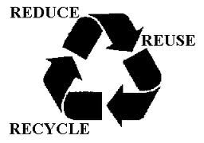
In keeping with Central Washington University’s goal to reduce our carbon footprint, we have reduced, reused, and recycled whenever possible in the planning and implementation of this conference. To help in this endeavor, please do not print this program – there will be one available for you when you get to the conference. Also, please deposit your nametag in the door prize drawing box at the business meeting so that you can possibly win a prize and the next planning team can reuse your name tag.
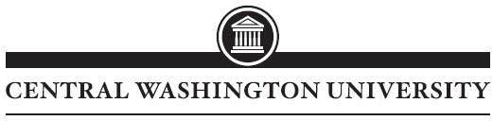

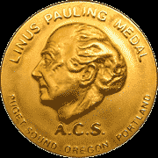2010 Linus Pauling Medal Award
For outstanding contributions to chemistry meriting national and international recognition
Awardee
Professor Armand Paul Alivisatos

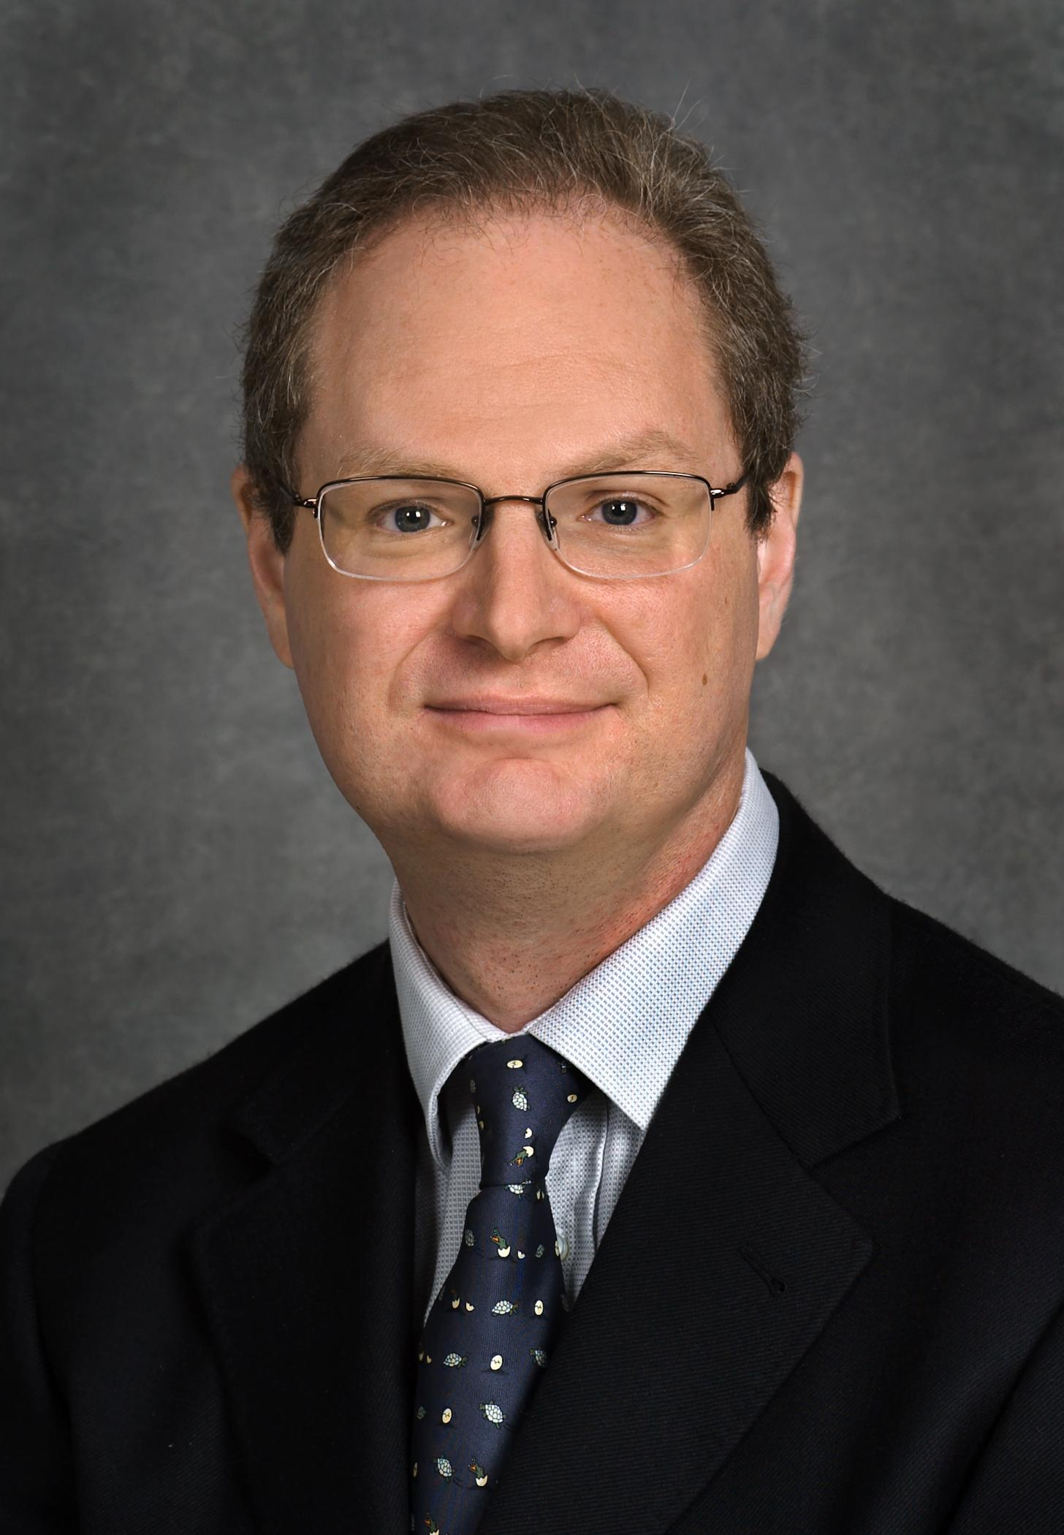

Larry & Diane Bock Professor of Nanotechnology,
University of California, Berkeley
Deputy Director, Lawrence Berkeley National Lab
Editor, Nano Letters

Symposium and Banquet Hosted by
The Evergreen State College on November 6th, 2010
Symposium Speakers: Professor Mostafa A. El-Sayed (Julius Brown Chair & Regents Professor, Georgia Institute of Technology), Professor Phillip Geissler (U.C. Berkeley), Professor Yi Cui (Stanford University)
http://blogs.evergreen.edu/pauling/

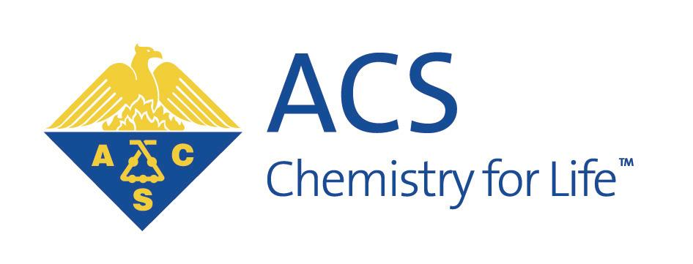Sponsored by the Puget Sound, Oregon, and Portland Sections of the American Chemical Society

